

Windows Backup Report Emailer
Date 4/5/2017
This document describes the process to install, setup and schedule the Windows Backup Report Emailer inside your LabTech / Automate RMM tool.

Prereqs:
You will need to obtain the P4L Backup Windows Reporting script XML import file.
Go to http://support.plugins4labtech.com/viewtopic.php?f=49&t=5250 and download zip file.

Directions:
- Unzip the XML file extracting to your desktop.
- Open your LabTech console and select from main menu. 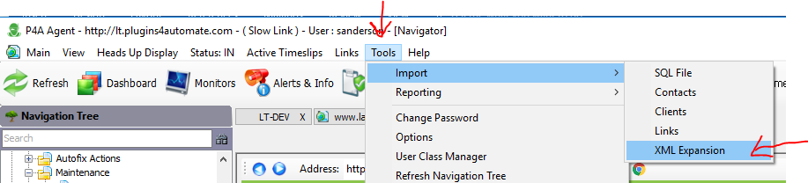
- Navigate to your desktop and select the XML file you have unzipped. 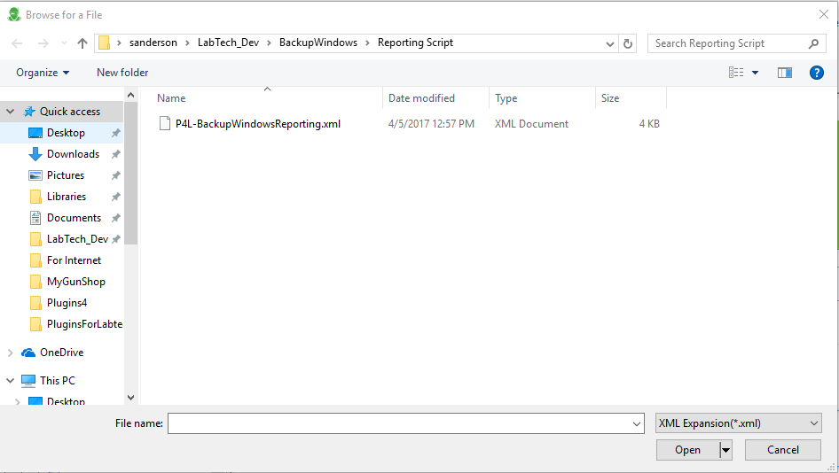
- Select Yes when prompted. 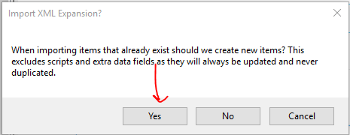
- You will now find the “P4L-BackupWindowsReporting” script under the Maintenance Subfolder of your scripts folder. Refresh your LT Cache if you do not see the script.
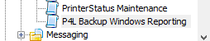
- Edit script, Line 2 of script is the varible that holds email addresses. Place one or more email addresses here seperated by a simi-colon (;) and save script. 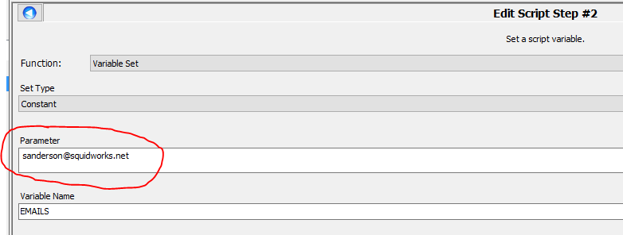
- Next find in LabTech the LT server’s agent and schedule the script against this agent setting the schedule to run “daily”. Adjust the hour that it runs so that you are allowing the backus to have completed “and” you allowed the Backup Windows scan to have also run. 

