Script #1 (P4A Deploy Chocolatey)

First, copy line 6 and add it as line7. Modify line 7 to reflect your location of chocolatey.
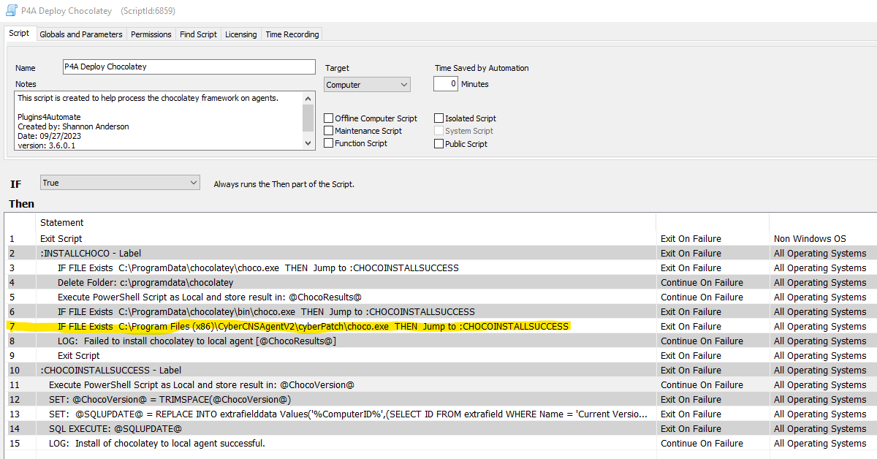
Next, on line 11, edit the PowerShell script to reflect your chocolatey location. If you are certain that choco is in the path. You can modify to be just choco -v -r
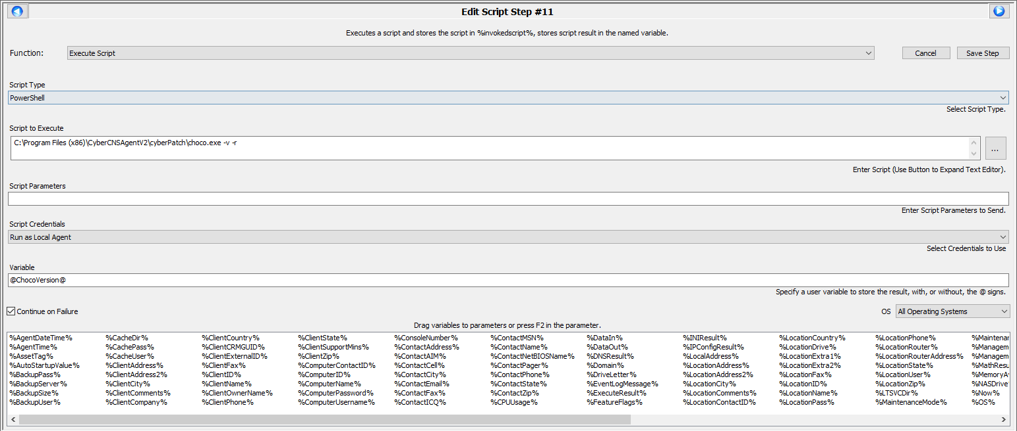

This should resolve your chocolatey deployment issue.

Script (P4A Chocolatey Auto Install Approved Applications)
Modify line 3, edit the script file that will be created to adjust for choco location.
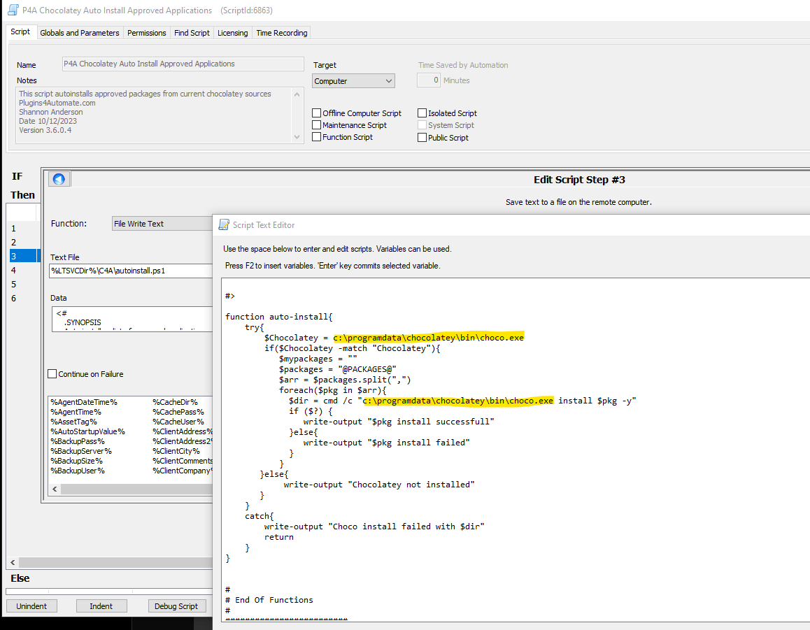

Script (P4A Scan Chocolatey Packages)
Edit script, line 5 updating the chocolatey location in 3 places.

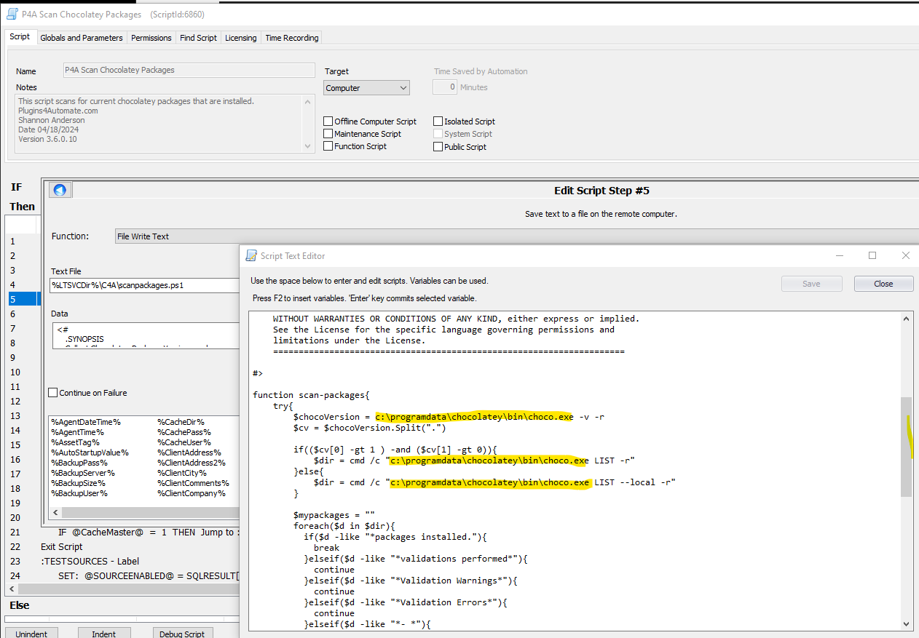

Edit Line 11, Modify choco location.
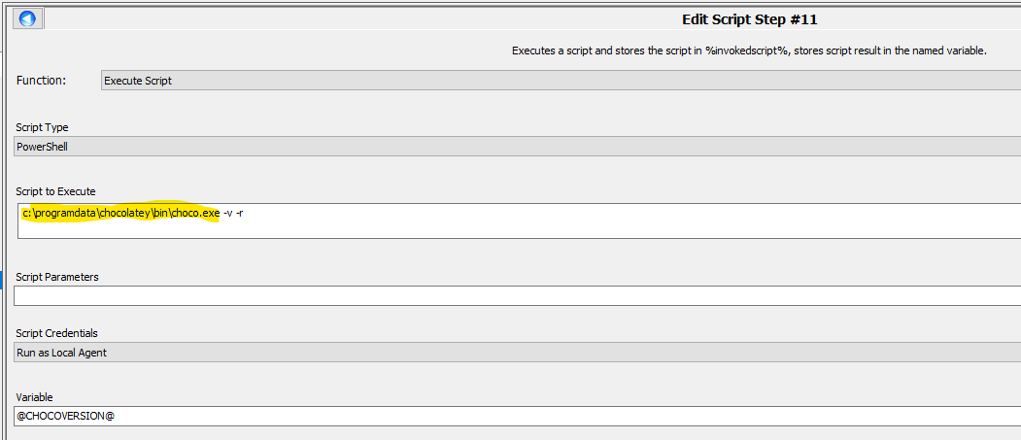

Edit Line 17, Modify the log locations for chocolatey in 2 places.
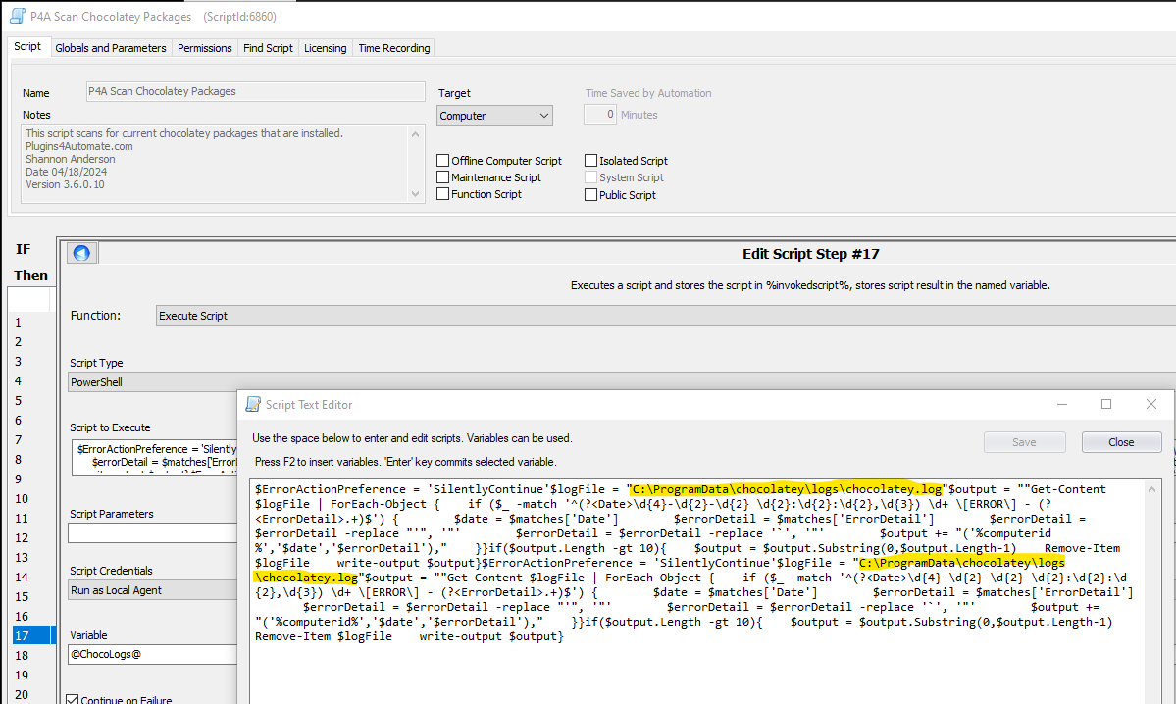

EDIT Line 30, modifying the script text file in 3 places.
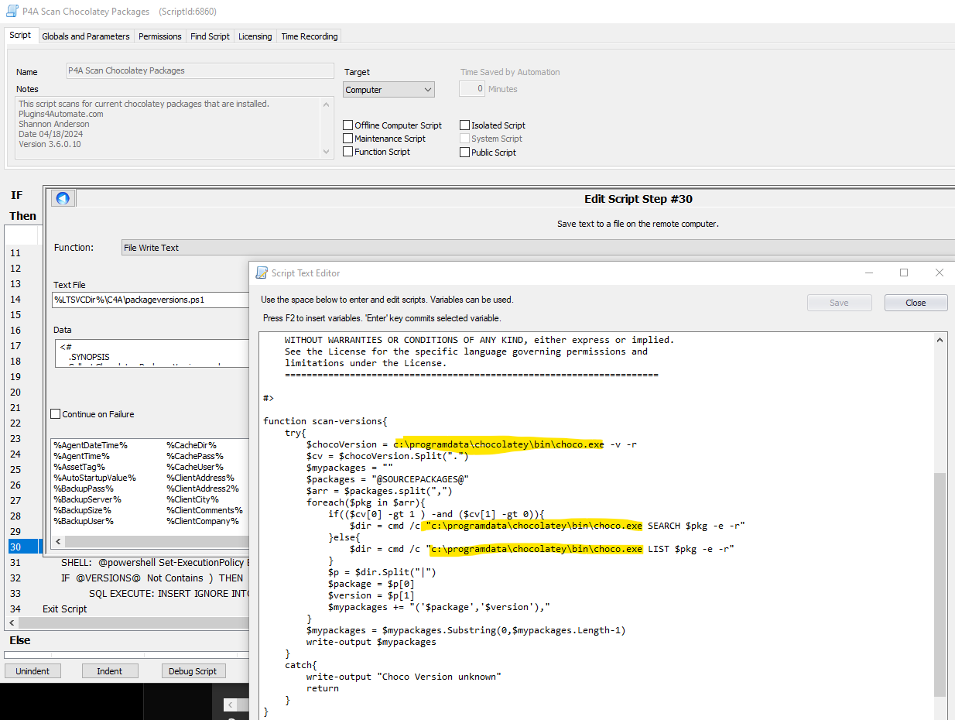

Script (P4A Chocolatey Sources)
Edit line 4, modify script text in 6 places


